**i.)Use case diagram**

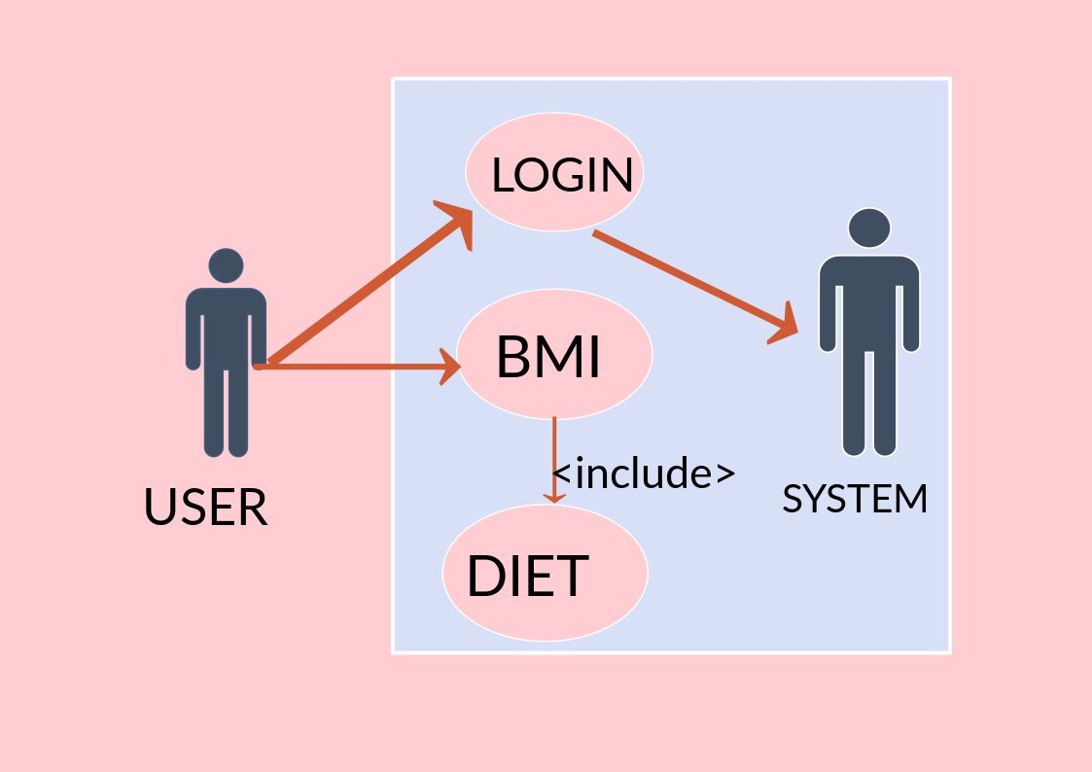

***Results:-***

***1.)First condition “A Person is overweight”***

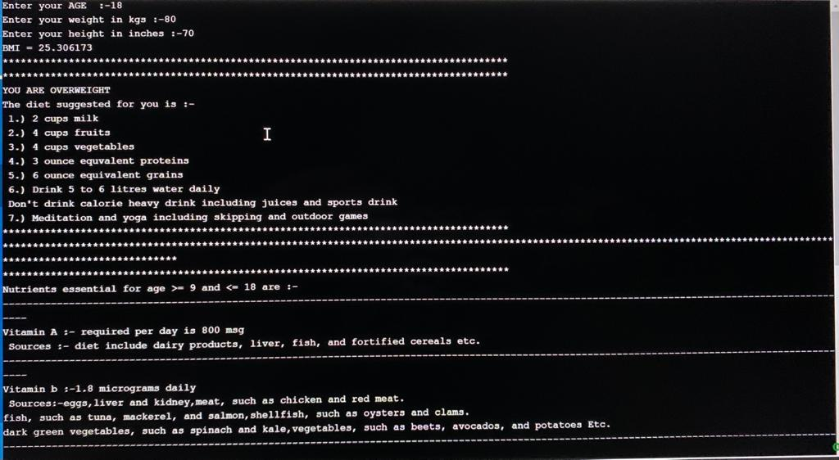

***2.)Second Condition “A Person is Normalwieght”***

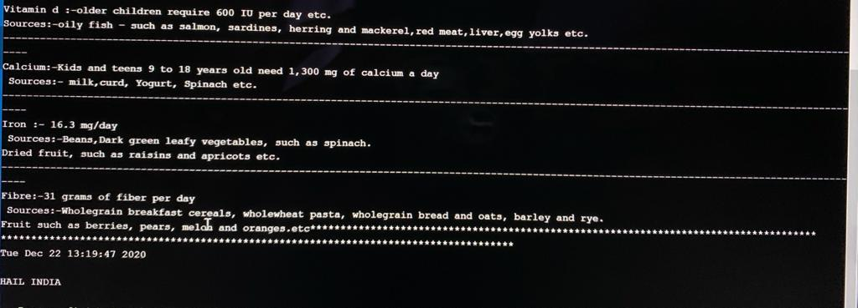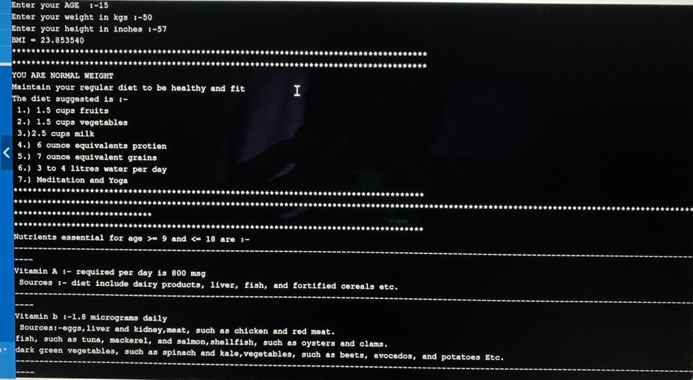

***3.)A Person is Obese***

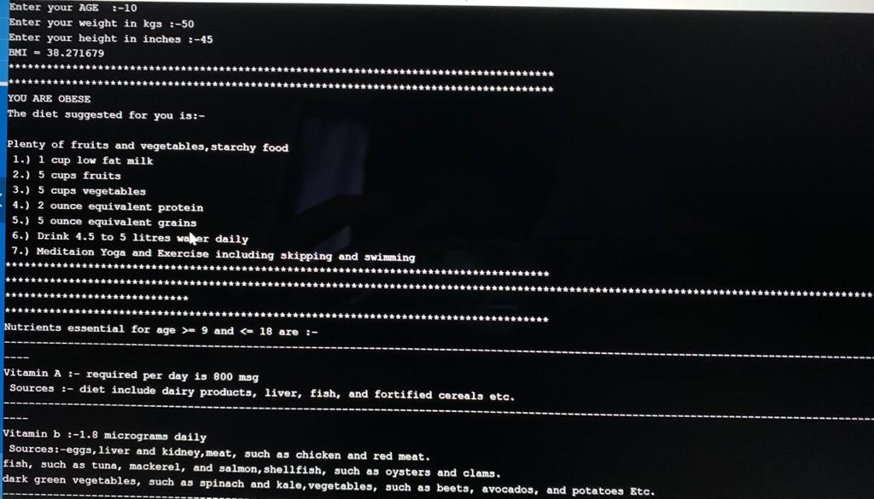

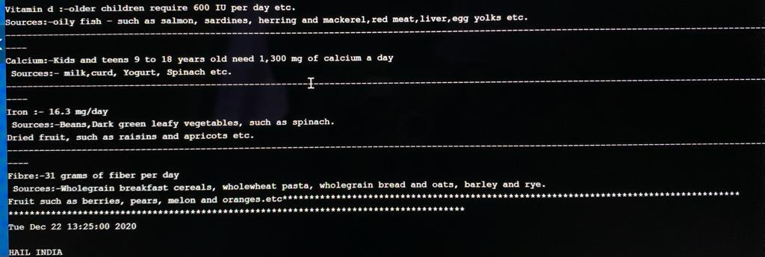

***4.)A Person Under Normal Weight Conditions***

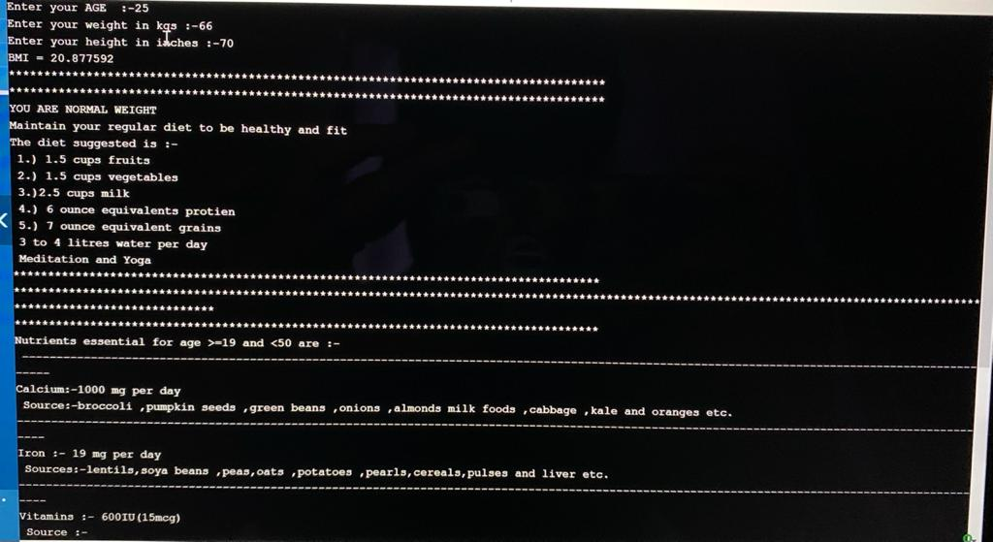

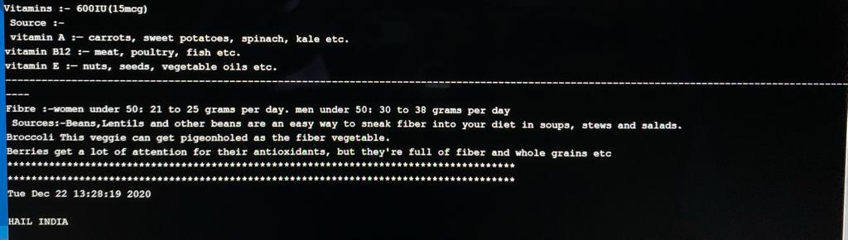

***ADDITIONAL IDEAS THAT WE LEARNT FROM DOING THIS MINI PROJECT IS***

***->WE LEARNED TO WORK AS A GROUP***

***->WE WERE TRUELY IN THE ABILITY OF ENHANCING OUR CODING SKILL***

***->WE HAVE ALSO LEARNT NEW THINGS THAT CAN BE IMPLEMENTED IN A PROGRAM***

***Implementing this project in C Language has introduced us to different libraries such as: ‘math.h’, ‘time.h’ and ‘windows.h’. We were able to use the knowledge of using standard libraries by implementing them in our project. We explored the ‘time.h’ library for achieving a look-and-feel of an actual window application by constructing our own time delay function.***

***CONCLUSION AND FUTURE WORK :-***

***We have implemented our code succesfully and our mini project is completely based on health . It primarily concentrates the health concerns that are being faced by the peolpe . Up to some extent we tried in writing a program for a healthy diet suggestion for the people and helping them to maintain a healthy and happy life .***

***The diet suggestions which we used in our program that are completely based on the norms that are certified by the world health organisation (WHO) and collected few from the recent statistics released by the Food corporation of India (FCI)***

***And we are very enthusiastic in developing an Application based on this idea (Helathy idea) and helping the people to pave their way to a W’healthy’ life.***

***Even though there are many apps of these kind in the present market but they are not that profound or well known to the people as they lack in marketing . But the app that we wanted to develop is a different one of the kind and through this marketing this app may become a successful one …………..***

**ABSTRACT**

***Introduction***

*Now a days in this busy world people are not bothering of their health conditions and falling sick very often.*

*What is this health? It is a state of complete physical,mental and social well being and not merely the absence of disease or infirmity.*

*Health is wealth which is a very profound slogan. Yes and that’s true if a person is healthy then he will be able work very actively and efficiently.*

*For good health not exercise and yoga but also a healthy diet is also required.*

*So in our project we are going to work on this.*

**PROJECT IDEAS**

*First a person has to enter his name, age, weight in kilograms and height in meters .*

*Then it calculates the BMI (Body mass index)*

*After calculating BMI we have classified the obtained BMI values into 4 categories.*

*For each category there will be a separate diet in that how many calories have to be taken per day including vitamins intake , and also how much water to drink a day and suitable sleeping times will also be suggested etc.*

*A decent diet is very important for a person to lead a healthy life. Health is the most precious this for an individual. So be wealthy by being healthy 💪🏻.*